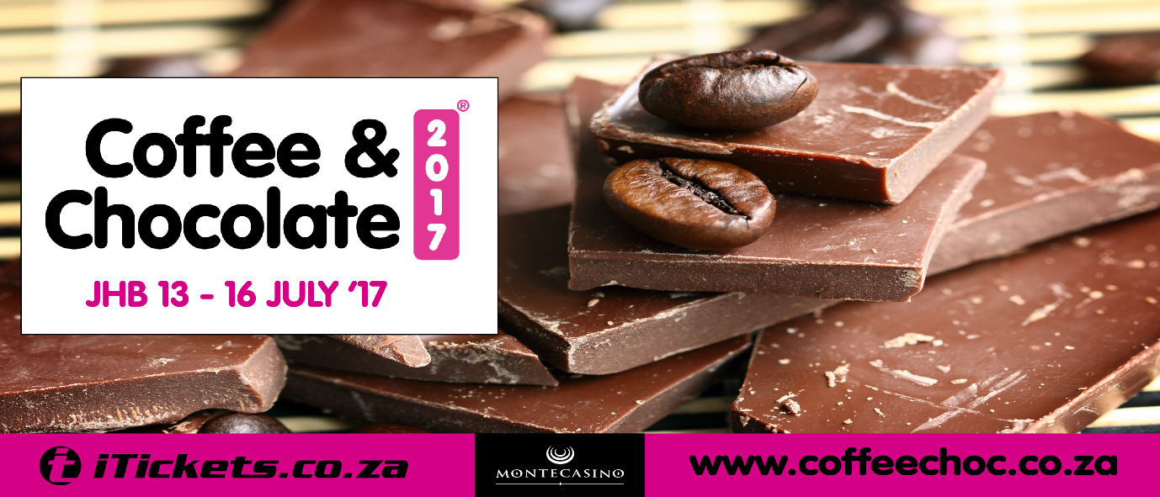

VIP TICKET INFO
A choice between an Espresto Wave / Delhonghi Drip Machine
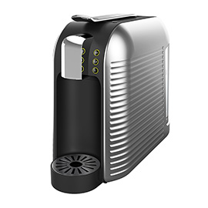

Our new sensational areas include:

• World Coffee Event – All Stars (NEW)
Over the course of 4 days, see some of the World Champion Baristas showcase their skills and coffee mastery through a series of interactive events, including: mystery drink challenges, pop quizzes, on-demand performances, meet-and-greets, and more! A very first for South Africa

- Roast your own Coffee (NEW)
Genio Roasters and The Coffee Company have teamed Genio Roasters and The Roasting Co. have teamed up to teach coffee enthusiasts about the entire process of roasting, packaging and brewing coffee with the help of experienced coffee professionals. From Green Bean to Cup, is this an experience in an easy and safe environment, which is a first in Johannesburg.

- Pairing Theatre
This sensation area hosts a culinary delight of Coffee & Chocolate and is home to our famous Pairing Theatre, pairing whiskey, wine, liqueurs with chocolate. Sample taste and celebrate all things delicious and decadent!

- Beyers Chocolate Workshop
Beyer’s Chocolates heads up our decadent Chocolate Workshop. Watch Kees Beyers and his culinary chocolatiers work their magic whilst learning up on all chocolate delights and recipes that create a visual feast. This experience is innovative, mind-blowing and keeps you on point on the latest Chocolate trends.

• Cocoa Mokka Music Lounge,
Celebrating SA’s up and coming artists whilst listening to vibey sounds or simply chilling with friends and family sipping on your favourite Chocolate Beer or Coffee and Chocolate wine.

ENDS

EDITORS NOTES:
- Over 160 exciting Coffee & Chocolate products to experience taste and buy from some of SA’s finest chocolate and coffee specialists.
- Key sponsors for 2017 are: Beyers Chocolates
- Show Dates:
JHB 13TH - 16TH JULY 2016 Montecasino - 35,000 visitors

TICKETS
Tickets can be purchased via iTickets.co.za
R120.00 pp online & at the door – kids under 10 free
Facebook: /CoffeeChocolateExpo
Twitter: @Coffeechocexpo #CoffeeChoc2017, #CoffeeChocEXPerience, #CoffeeChocEXP
You Tube Link : https://www.youtube.com/channel/UCRXoUwnh2f0J18PHAr6r6fg
Website : www.coffeechoc.co.za
World of Coffee Events http://www.worldcoffeeevents.org/all-stars/all-stars-johannesburg/

TIMES
Thurs 13th July 16h00 – 22h00
Fri 14th July 10h00 – 22h00
Sat 15th July 10h00 – 22h00
Sun 16th July 10h00 – 18h00

